**Computational Thinking - Warm-Up #1 (2024)**

| **Tangrams** |
| --- |

Tangrams are an ancient puzzle, and an interesting starting point for learning about Computational Thinking. With these seven Tangram shapes, thousands of different objects can be constructed:



For instance, here is a house object made from Tangrams:

 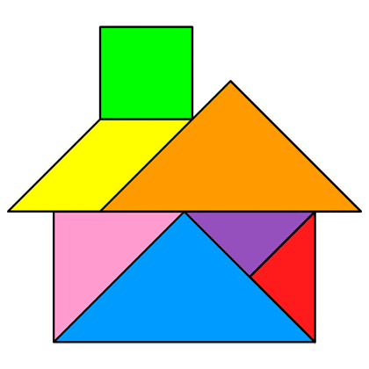

| **Exercise #1: Solve a Tangram Puzzle.** |
| --- |

1. Visit [Amplify’s Polypad - Tangram Builder](https://polypad.amplify.com/tangram):

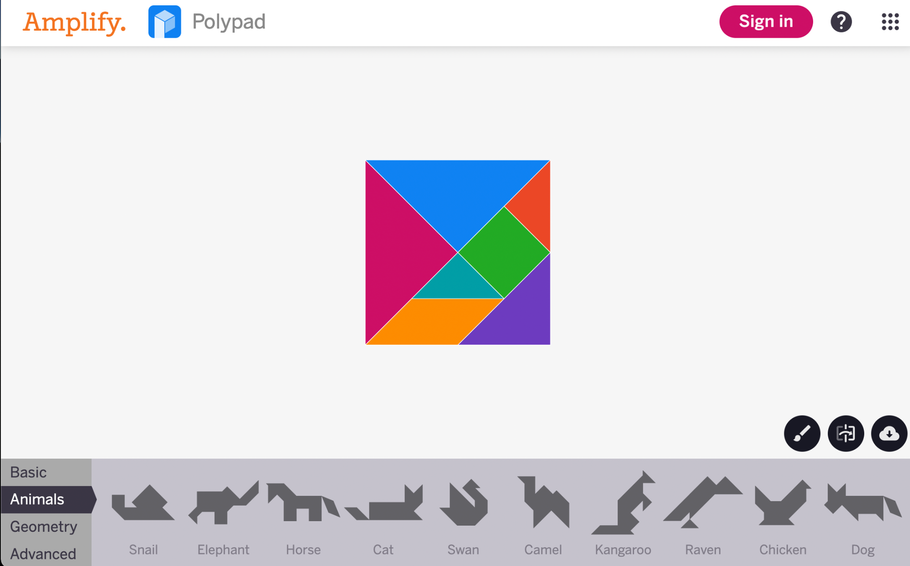

1. Pick a tangram puzzle to solve by dragging and rotating the 7 tangram shapes.
   1. Feel free select a puzzle from any of the four categories: Basic, Animals, Geometry, Advanced
   2. Don’t pick the house puzzle as it’s solved above
2. Download your tangram as a PNG using the button in the bottom right hand corner.
3. Rename the tangram image as **tangram_solution_<your_name>.png**

| **Exercise #2: Write instructions for solving the puzzle.** |
| --- |

1. Create a Google Doc containing a single Numbered List: 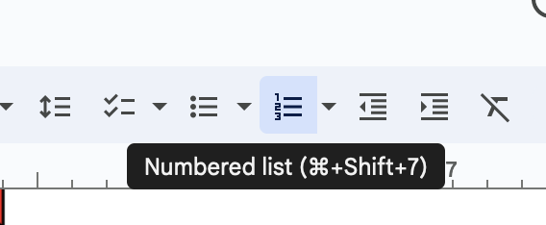
2. Without including the name of the tangram puzzle you solved, (or any other “hints”), write a complete set of instructions for someone else to follow in order to solve the tangram puzzle.
   1. **You should assume that the person following the instructions will have a set of tangrams to manipulate on their desk.** They will not have access to a computer, or the [Amplify’s Polypad - Tangram Builder](https://polypad.amplify.com/tangram) website.



* 1. Note: One of your peers will follow these instructions on the first day of class.

1. Download your instructions as **tangram_instructions_<your_name>.pdf**

| **Submit your materials to the Computational Thinking Warm Up #1 Assignment on Gradescope.** |
| --- |

1. Visit the Gradescope link for your class
2. Click on the Computational Thinking Warm-Up #1 Assignment
3. Upload the two files you created for this assignment:
   1. **tangram_solution_<your_name>.png**
   2. **tangram_instructions_<your_name>.pdf**
4. Answer the following questions:
   1. How confident are you that someone will be able to follow your instructions to exactly reproduce the Tangram solution? Explain your reasoning.
   2. What were some of the more challenging aspects of writing instructions for solving the tangram puzzle?